**Appointment Shadowing on Teams**

This procedural document is for training purposes and will guide the trainer on the steps to take for having a new hire shadow a call as part of their training. These are the steps to take to successfully do so on the Microsoft Teams application.

1. Call employee through Teams (not Cisco phone).

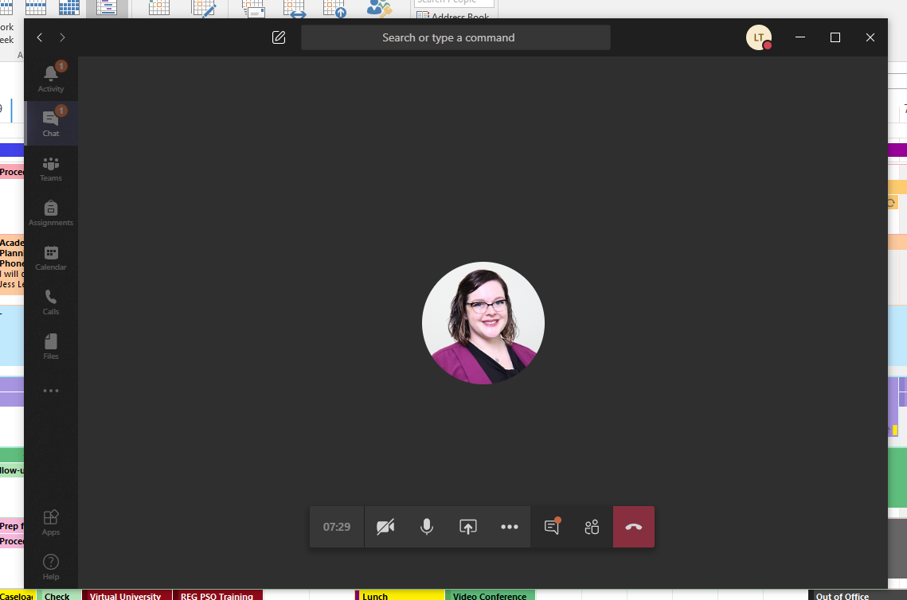

1. You will need to share your screen with them in order for them to view what you are doing while in the appointment.

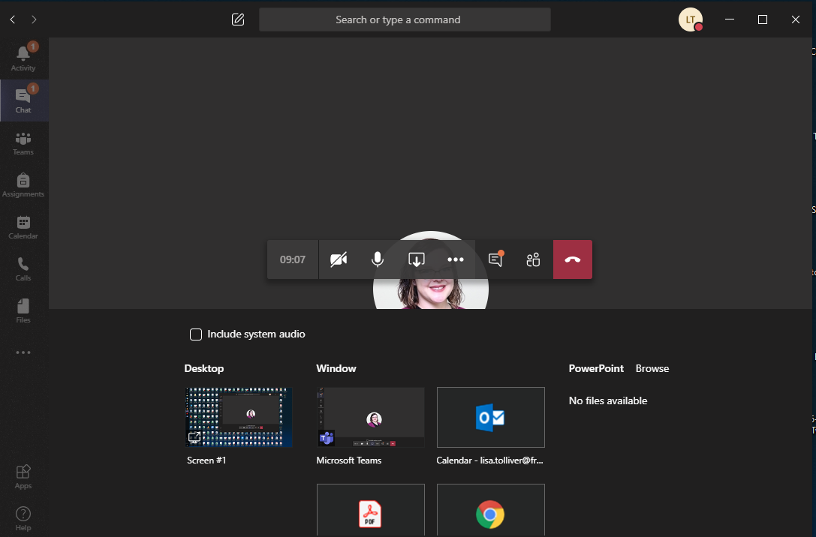

1. Click on the “Participants” icon



1. When you see the participants listed, there will be a space that says “Invite someone or dial a number”. Here is where you will dial the phone number of your appointment and push enter to start the call.

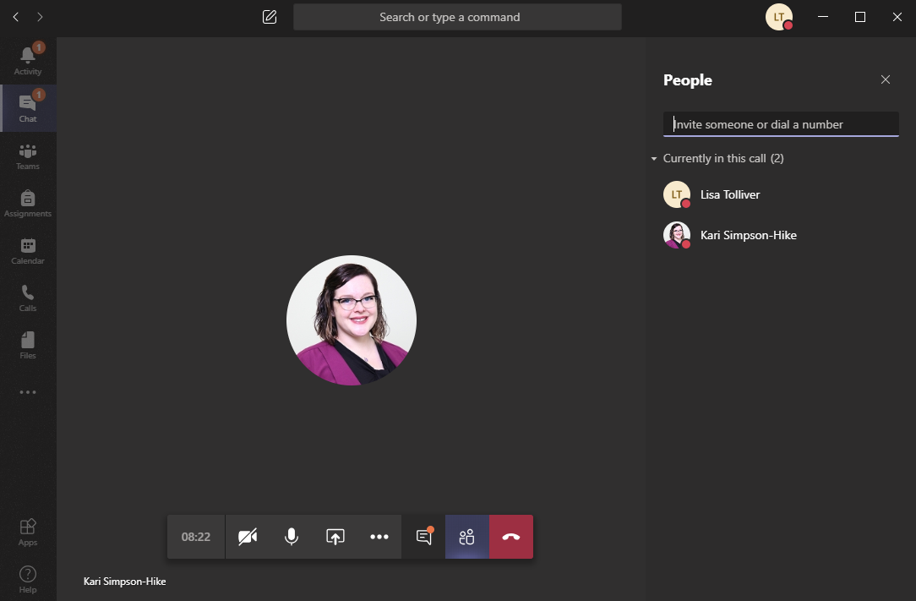

*The number that comes up for the students is a 614 number and will never be the same number every time. This means that if a student doesn’t answer, you will leave a message with your desk number to call back, as the student will not be able to reach you by calling back the Teams number that displayed.